***Experiment 2 (Cyber Security Lab)***

**Protocol hierarchy:**

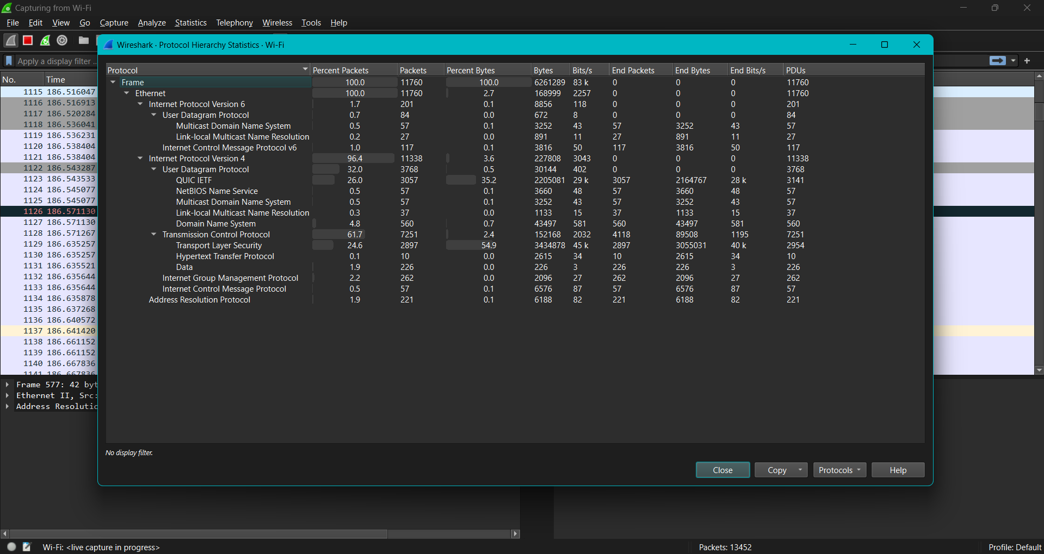

**Sec-sick client:**

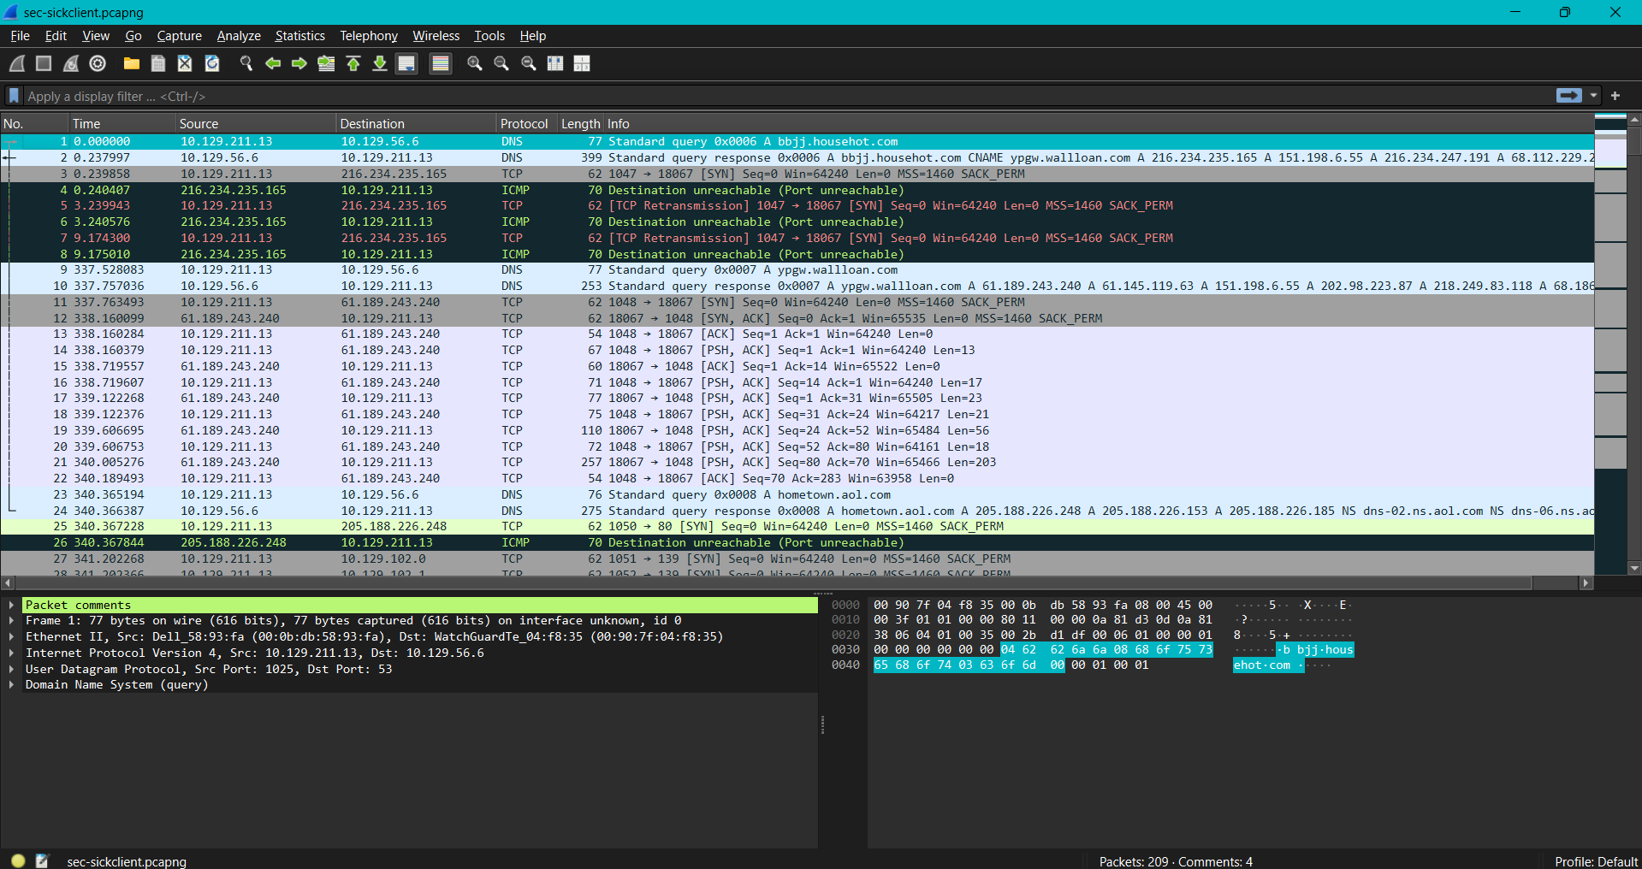

**Aurora (line 6 -iFrame attack & line 21 -gif data observation):**

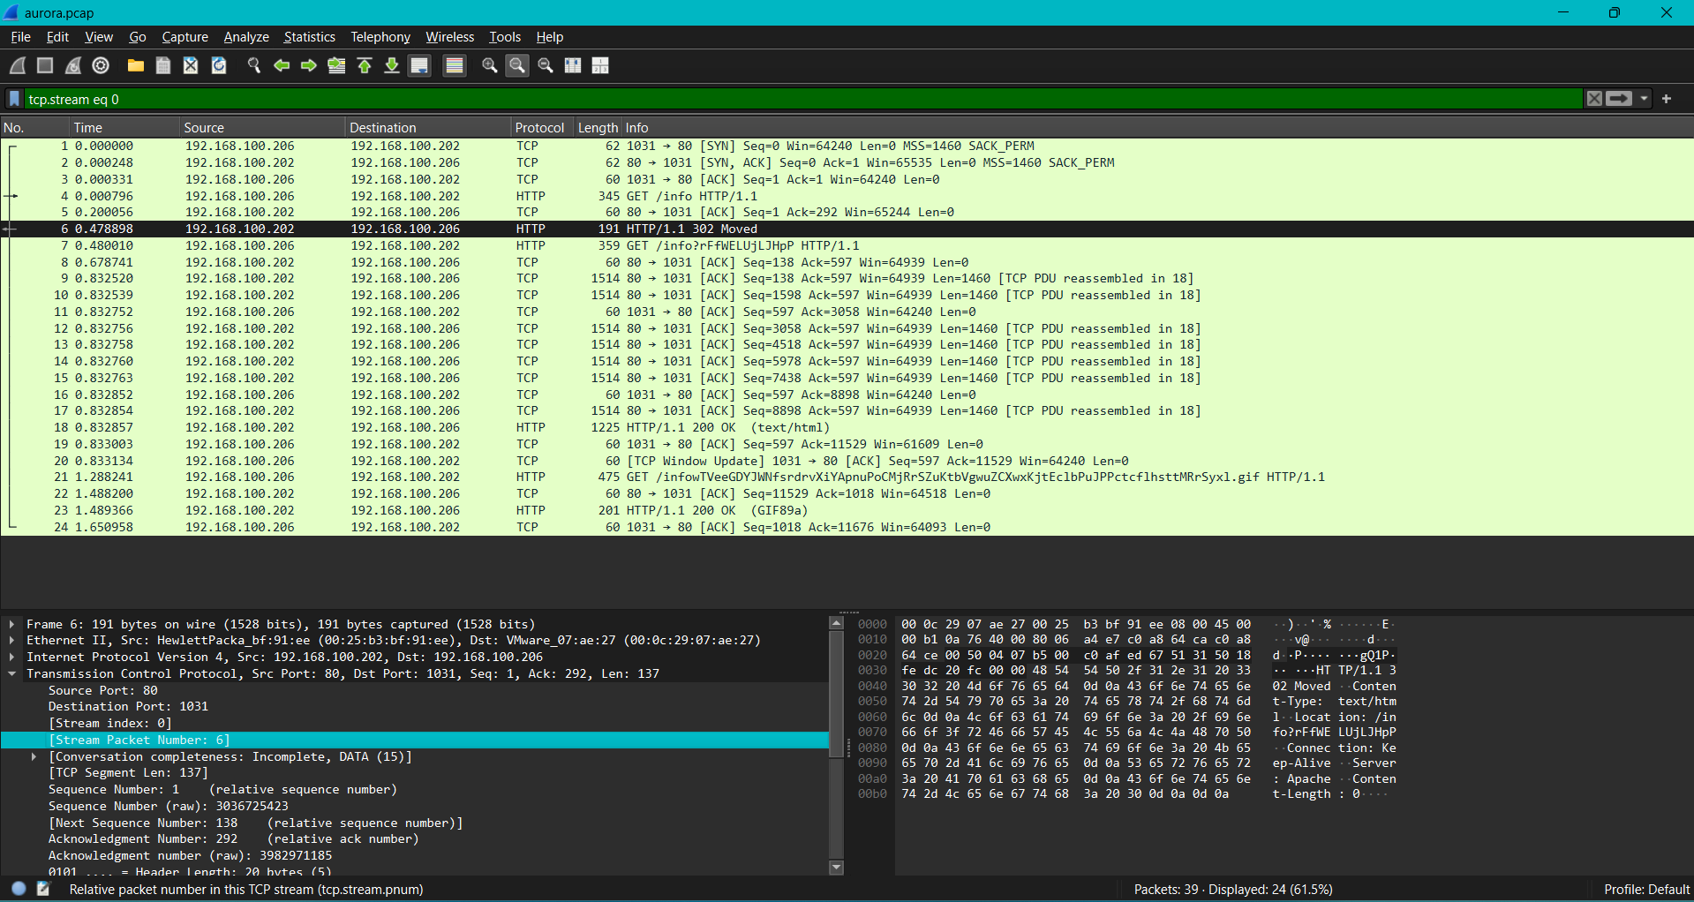

**Aurora (line 6 -TCP stream observation):**

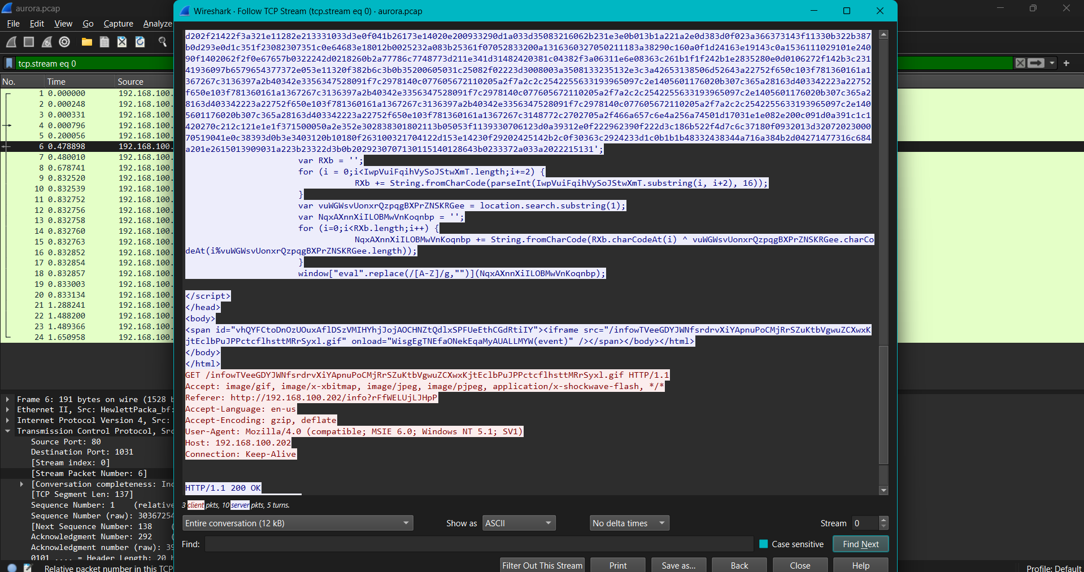

**Aurora(line 25-TCP Stream obsevation):**

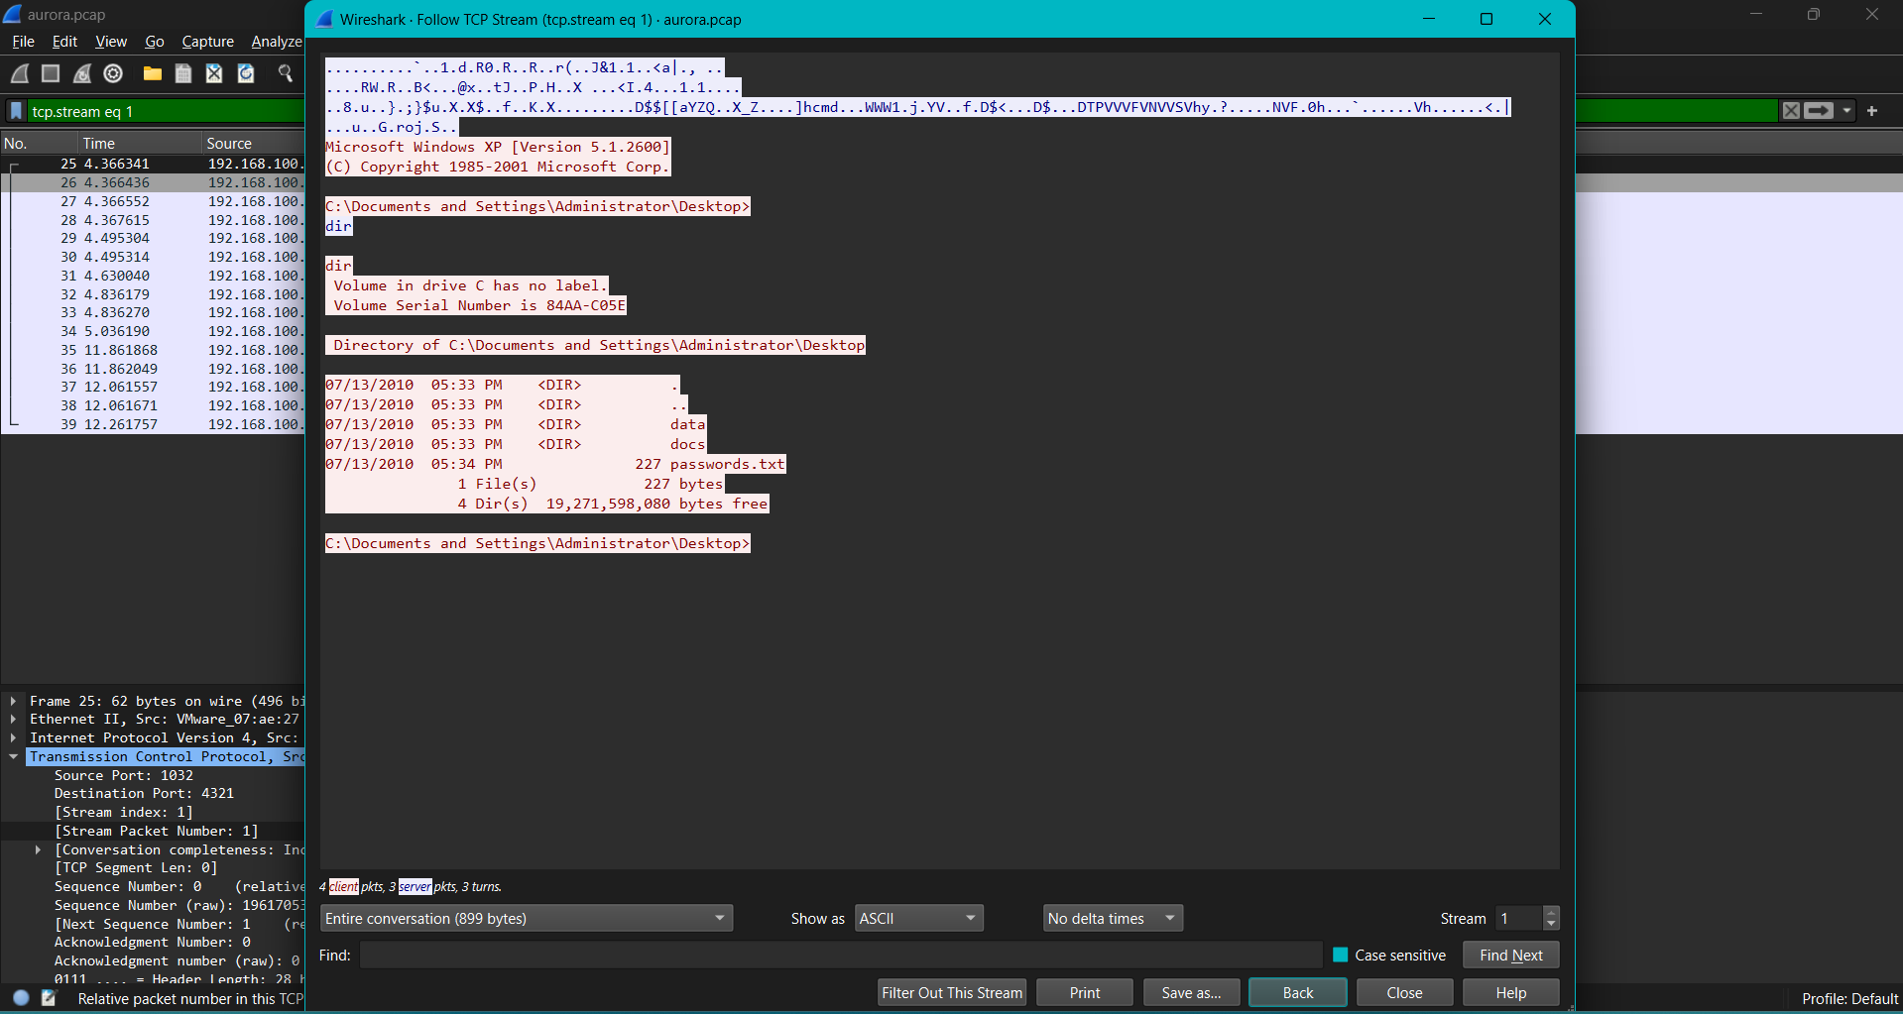

**Arp poison (line 54, 55, 56 &57 -man in the middle attack observation):**

